Bridgepoint Parts Catalog

Section X: Oil Fired Heater Systems Page 1

PP36-900072

Magneto

Prochem: 100A, 150
& Oil Fired TM

Repair Parts:
Coil: PP33-900076
Points: PP33-900074
Condenser: PP33-900078
Cover: PP33-900077
Cover Gasket: PP33-900081
Bearing – Inner: PP45-802141
Bearing – Outer: PP45-802140

PP33-900082

Electrode - Left

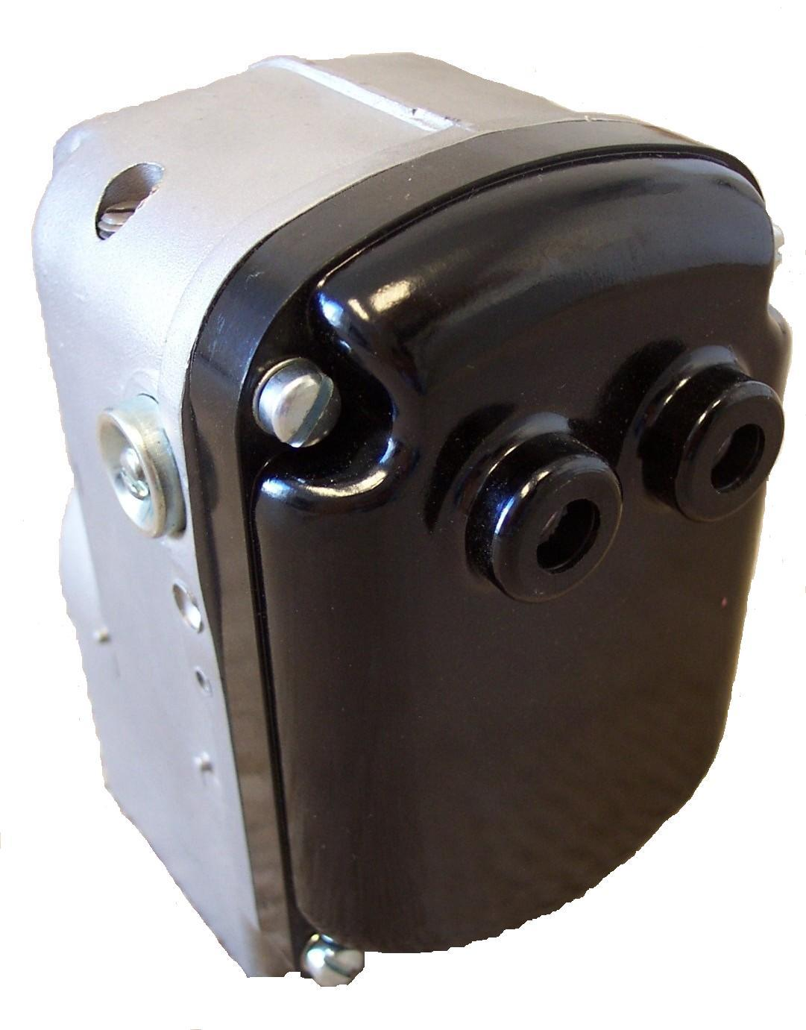
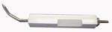

PP33-900083

Electrode - Right

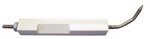

PP64-950100

Wire - Ignition

Sold individually
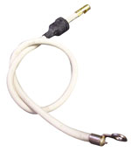

PP61-950160

Burner Assembly

Assembly Components:
Electrode Left: PP33-900082
Electrode Right: PP33-900083
Nozzle: PP17-803019
Adapter: PP17-803014
Electrode Plate: PP56-500688
Burner Body: PP56-500681

PP17-803019

Nozzle - Burner

PP17-803014

Adapter – Burner Nozzle
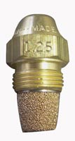
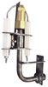

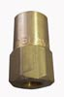

PP61-950157

Bearing & Plate Assembly

PP56-500681

Burner Body
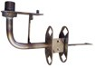
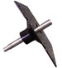

PP56-500688

Electrode Plate

PP44-802137

Impeller

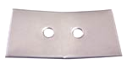
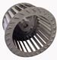

PP41-809055

Fuel Oil Pump

PP44-802140

Flexible Coupler

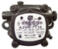
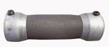

PP44-802103
Belt – Burner / Magneto
Prochem: 150

PP35-901004

Solenoid Valve – Kerosene

12VDC

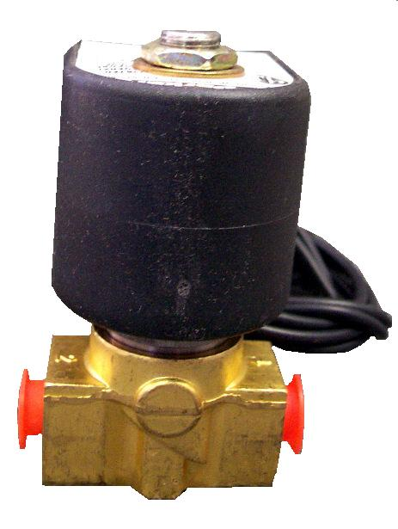

PP44-802234
Belt – Burner / Magneto
Prochem: Oil Fired TM

PP44-802113
Belt – Burner / Magneto
Prochem: 100A

Bridgepoint Parts Catalog

Section X: Oil Fired Heater Systems Page 2

PP14-806520

Filter Assembly – Kerosene

Replacement Filter Element:
PP14-806521

PP56-500665

Burner Cone

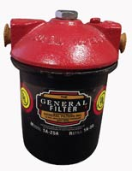
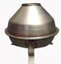

PP57-520010

Heater Coil
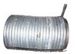

PP15-808042

Flow Control

Prochem: Oil Fired TM (old style)
100A & 150

Repair Parts:
Diaphragm: PP16-808159
Shaft: PP16-808156
Lever Outside: PP16-808154
Lever Inside: PP16-808150
Stem & Disc: PP16-808152
Spring: PP16-808149
O-ring Shaft: PP43-810012
O-ring Gland: PP43-810003

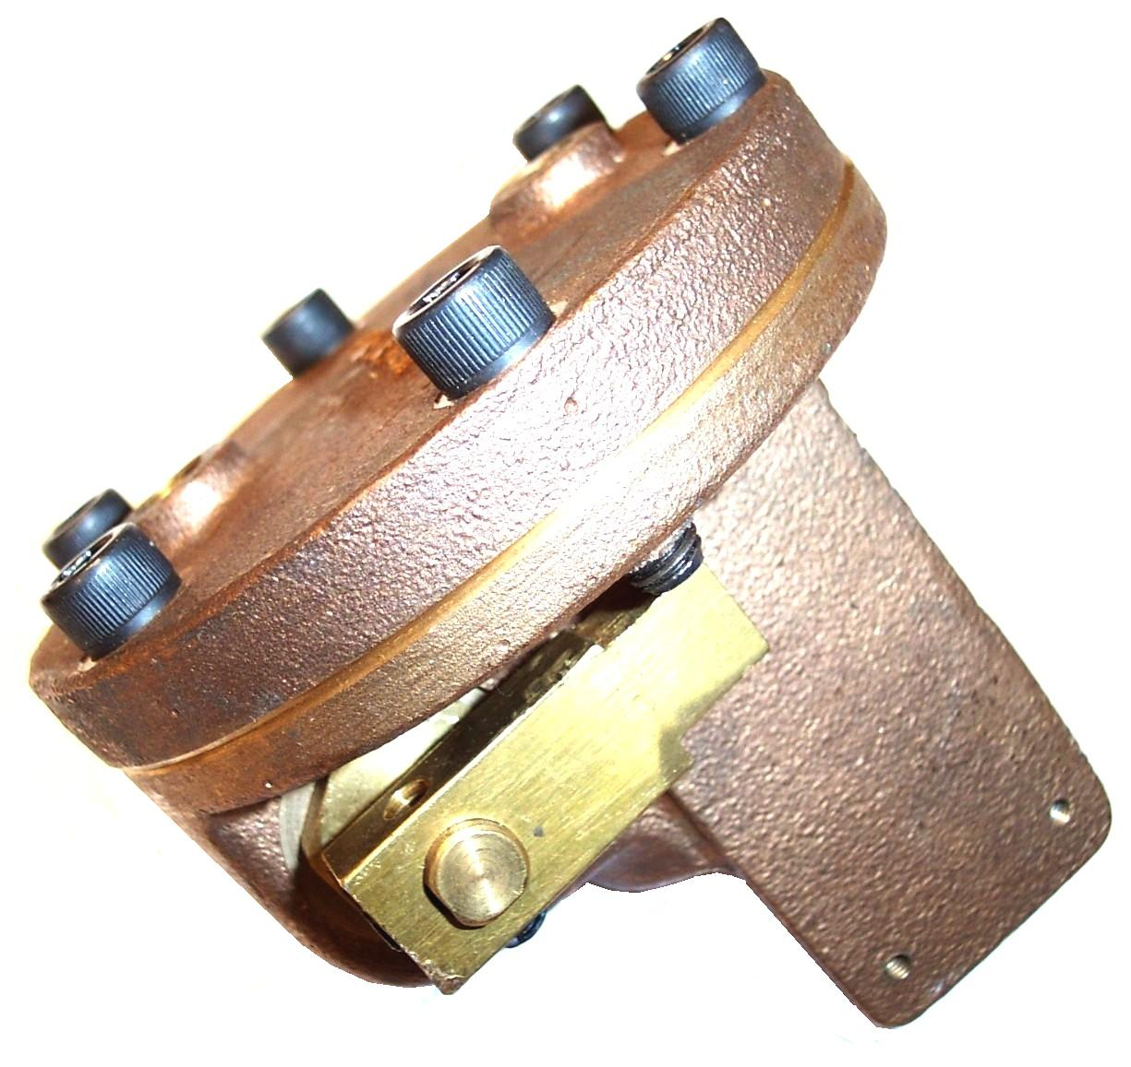

PP47-700002

Baffle - Coil

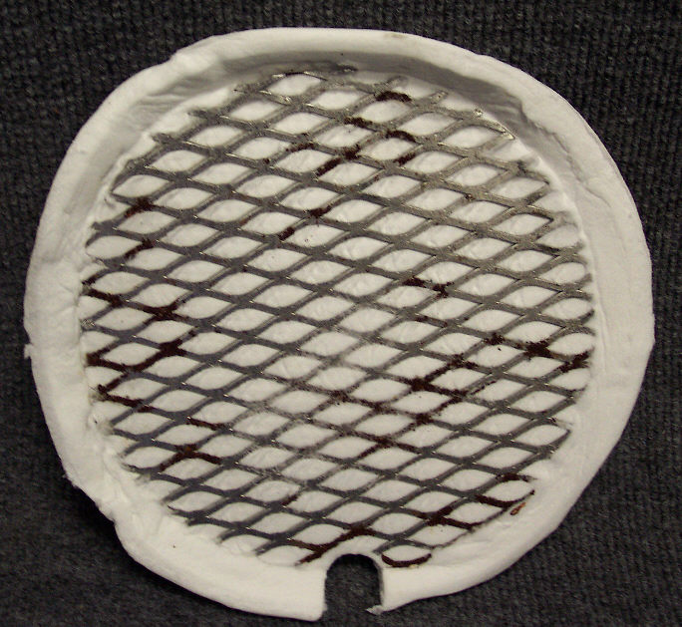

PP47-700004

Insulation – Heater End Plate

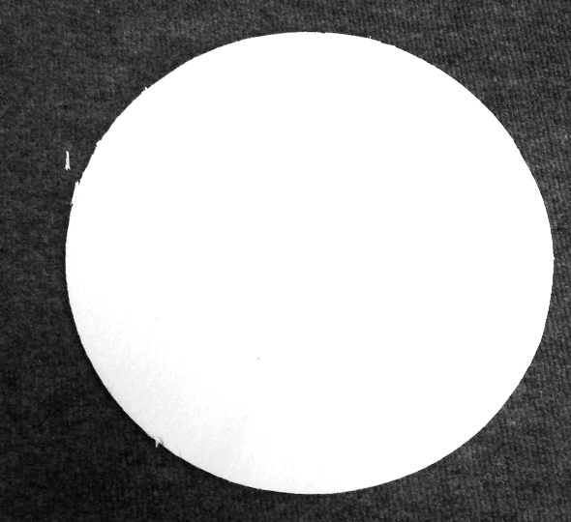

PP47-700005

Heat Shield - Burner

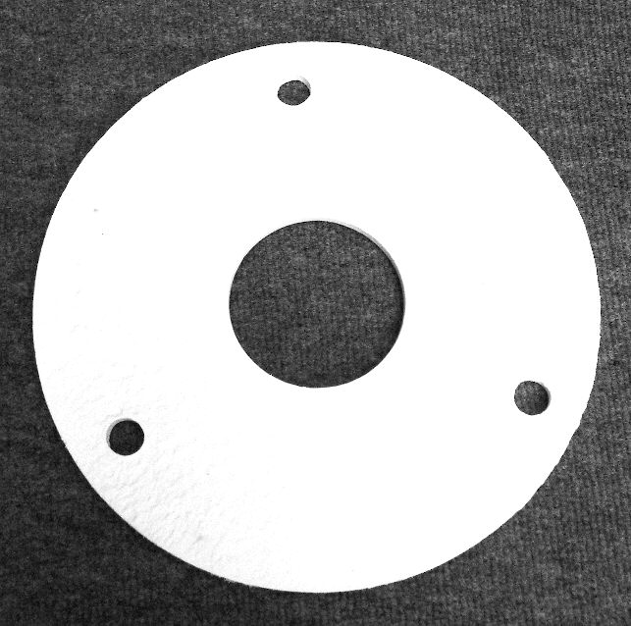

PP18-808508

Fuel Pressure Gauge

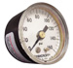

PP35-901007

Microswitch – Flow Control

Prochem: Oil Fired TM (old style)
100A & 150

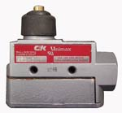

PP34-903002

Fuel Level Gauge

Prochem: 150
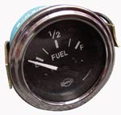

PP32-900087

Toggle Switch – SPST

Prochem: Burner Switch
100A & 150

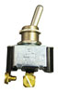

PP56-903003

Fuel Level Sensor

Prochem: 150
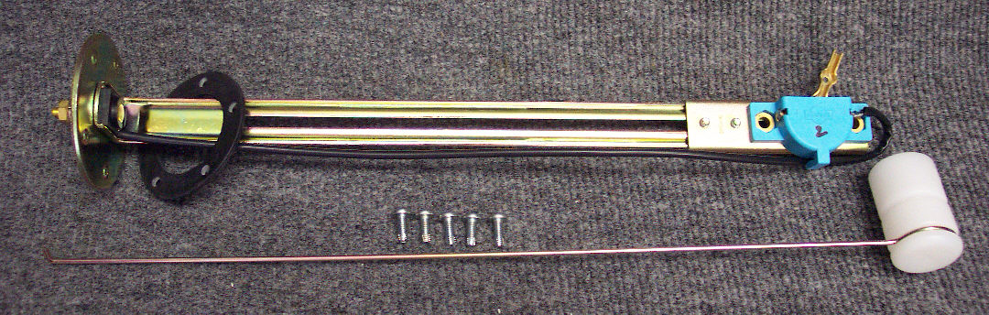

PP32-900196

Flow Switch HPF-920

Prochem: Oil Fired TM (new style)

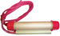

PP15-808032

Check Valve – 1/2” FPT - Brass
(Prochem part # 15-808151)

Prochem: Old style outlet check valve before use of outlet manifold assembly. Cub, CubXL, 800A, 100A, 150 & Oil Fired TM

Repair Parts:
Valve Assembly: PP15-808100
O-Ring - Seat: PP43-810008
O-Ring – Cap: PP43-810079
Seat: (SS) PP16-808223
Spring: PP16-808224
Poppet: PP16-808226
Insert: (Teflon) PP16-808225

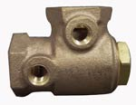

PP15-808027

Check Valve – Differential

Brass - 1/2” FPT

Prochem: 100A, 150 & Oil Fired TM

PP56-500641

Exhaust Stack – Outlet

Prochem: 100A, 150 & Oil Fired TM

